RESOLUTION NO.__________

RE: CERTIFICATE OF APPROPRIATENESS UNDER THE
PROVISIONS OF THE ACT OF THE PENNSYLVANIA
LEGISLATURE 1961, JUNE 13, P.L. 282 (53
SECTION 8004) AND BETHLEHEM ORDINANCE NO.
3952 AS AMENDED.

WHEREAS, it is proposed to restore the existing sign, add a sign below the existing and change previously approved fence color to white at the Sun Inn, 564 Main St.

NOW, THEREFORE, BE IT RESOLVED by the Council of the City of Bethlehem that a Certificate of Appropriateness is hereby granted for the proposal.

Sponsored by: (s)

(s)

ADOPTED BY COUNCIL THIS DAY OF

(s)
President of Council

ATTEST:

(s)
City Clerk

HISTORICAL & ARCHITECTURAL REVIEW BOARD

The applicant proposes to restore the existing sign, add a sign below the existing and change previously approved fence color at the Sun Inn, 564 Main St.
APPLICATION #4:

Sun Inn Preservation Association
564 Main St.
Bethlehem, PA 18018

OWNER:

__________________________________________________________________________

The Board upon motion by Beth Starbuck and seconded by Marsha Fritz adopted the proposal that City Council issue a Certificate of Appropriateness for the following:

- Existing sign will be repaired and repainted.

2. The new sign will match in color and letter style and be connected to the upper
sign with metal rods painted black with a black bracket.

3. The new fence approved at the May 2016 HARB meeting will be stained off-
white to match the sash.

4. The new sign will also have 4” gold leaf letters on a white background.

5. The sign will also be double-sided.

6. The motion was unanimously approved.

__________________________________________________________________________

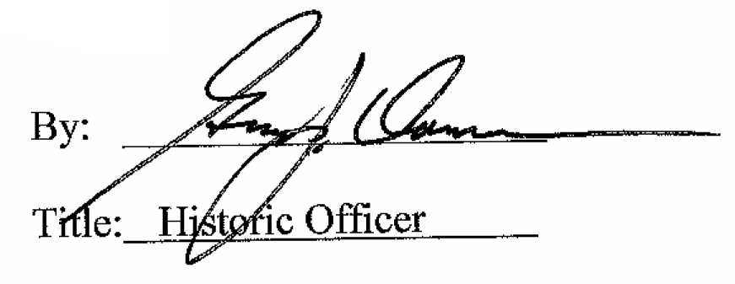

Date of Meeting: June 1, 2016

